Test Question 1
(c) Illustrate the concept of “the Chasm” in relation to the adoption life cycle with a diagram? [5 marks]
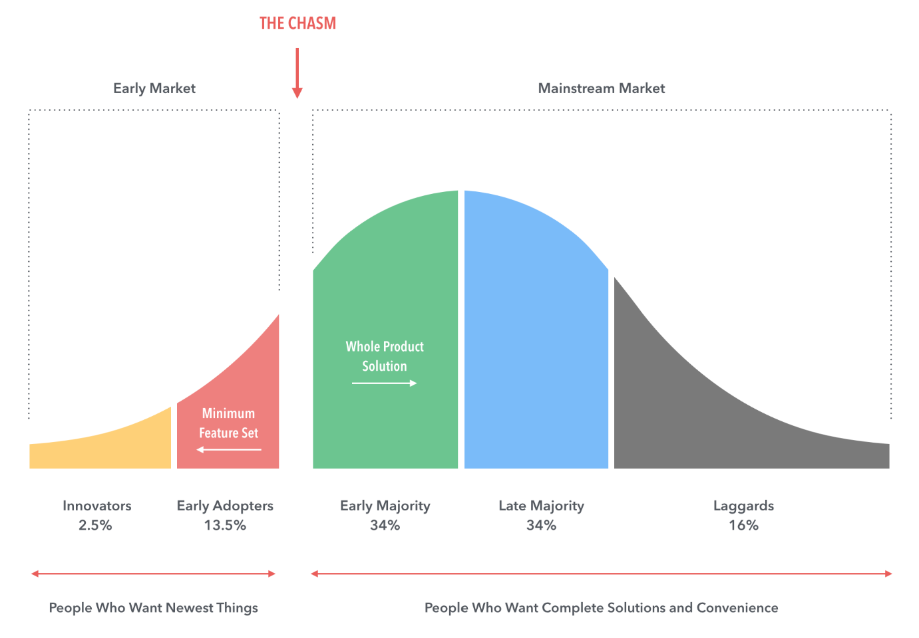
In the adoption of a new technology, from the early adopters to the early majority, there is always a gap in the new technology adoption lifecycle. This gap is called the chasm. It is usually a gap that is used as an evaluation by the early adopters before joing the early majority. This gap illustrates the evaluation that exits in the decision-making process of a person before deciding to either join the acceptors of the new technology or receed back to skepticism about the new technology in the market.
(d) Describe the concept of “Crossing the Chasm” in relation to the adoption life cycle? [5 marks]
The concept of crossing the chasm in relation to the adoption life cycle of adoption is the process of crossing from one segment to another. The process of crossing from early adopters to the early majority is what is referred to as crossing the chasm. Crossing the chasm happens ones one has evaluated and made up their minds to cross from early adopters to joining many others that have already accepted the new technology. That gives the company an opportunity to grow and expand.

